**NITTE MEENNAKSHI INSTITUE OF TECHNOLOGY**

***(AN AUTONOMOUS INSTITUTION TO VISVESVARYA TECHNOLOGICAL UNIVERSITY***

***BELGAUM,APPROVED BY AICTE & GOVT.OF KARNATAKA***



**Application Development using C++**

**on**

**Super Market Billing System**

**Submitted in partial fulfilment of the requirement for the award of degree of**

***BACHELOR OF ENGINEERING***

***in***

***Computer Science and Engineering***

***Submitted by:***

1. ***Pradeep kumar raut 1NT19CS138***
2. ***Chethan sr 24068***
3. ***Rizwan ansari 1NT19CS160***
4. ***Narashimha reddy 24076***
5. ***Hemantha 24398***

*Under the guidance of*

*Dr.VIJAYA SHETTY*

*Assistant professor,Dept.of CS&E,NMIT*



***Department of Computer Science and Engineering***

***(Accredited by NBA Tier-1)***

***2020-2021***

**NITTE MEENNAKSHI INSTITUE OF TECHNOLOGY**

***(AN AUTONOMOUS INSTITUTION TO VTU) BELGAUM,APPROVED BY AICTE & GOVT.OF KARNATAKA***

***Department of Computer Science and Engineering***

***(Accredited by NBA Tier-1)***



This is to certify that phase II report on "**Super market billing system** "is an authentic work carried by **Pradeep,Chethan,Rizwan,narshima reddy** bonafide student of **Nitte Meenakshi Institute technology,** Bangalor in partial fulfilment for the award of the degree of **Bachelor of Engineering** in **COMPUTER SCIENCE AND ENGINEERING** of Visvesvara ya Technological University,**Belagavi** during the academic year **2020 -2021.** It is certified that all corrections and suggestion indicated during the internal assignment has been incorporated in the report.

**Internal Guide Signature of HOD**

**Dr.VIJAYA SHEETY'S Dr.Tippeswamy.M.N**

**Assistant professor,Dept.CSE, Professor,HEAD,Dept.cse,**

**NMIT Bangalore NMIT Bangalore**

**DECLARATION**

We hereby declare that

(i) This Presentation does not contain text, graphics or tables copied and pasted from the

Internet, unless specifically acknowledged, and the source being detailed in the report and

in the References sections.

(ii) All corrections and suggestions indicated during the internal presentation have been

incorporated in the report.

(iii) Content of the report has been checked for the plagiarism requirement

**Name USN SIGNATURE**

Pradeep kumar raut 1NT19CS138  Chethan shetty 24068 

Rizwan Ansari 1NT19CS160 

Narshima reddy 24076 

Hemantha Na 24398 

**ACKNOWLEDGEMENT**

The satisfaction and euphoria that accompany the successful completion an task would be incomplete without the mention of the people who made it possible, whose constant guidance and encouragement crowned our effort with success. We express our sincere gratitude to our Principal Dr. H. C. Nagaraj, Nitte Meenakshi Institute of Technology for providing the facilities.We wish to thank our H.O.D, Dr. Thippeswamy MN for the excellent environment created tofurther educational growth in our college. We would also thank him for the invaluable guidance provided which has helped in the creation of a better technical report.We also want to thank Dr. Vijaya S Shetty, Associate Professor, Department of Computer Science and Engineering for her periodic inspection, time to time evaluation of the project andthe extended help to make this project a success.We also thank all our friends, teaching and non-teaching staff at NMIT, Bangalore, for all the direct and indirect help provided in the completion of the presentation.

***CONTENTS***

*1. OVERVIEW OF OOP*

*2. INTRODUNCTION*

*3. SYSTEM REQUIREMENTS*

*4. Objective of the proposed system*

*5. Advantage of the proposed system*

*6. Function Used in the program*

*7. Working*

*5. SOURCE CODE*

*6. SAMPLE OUTPUT*

**OVERVIEW OF OOP**

OOP is a statically typed, compiled, general purpose, case sensitive, free-form programming language that supports procedural, object-oriented, and generic programming. OOP is regarded as a middle-level language, as it comprises a combination of both high-level and low-level language features.OOP was developed by Bjarne Stroustrup starting in 1979 at Bell Labs in Murray Hill, New Jersey as an enhancement to the C language and originally named C with Classes but later it was renamed OOP in 1983. OOP is a superset of C, and that virtually any legal C program is a legal OOP program. The most important thing to do when learning OOP is to focus on concepts and not get lost in language technical details.This software is developed in the programming language OOPavailable in the syllabus of CBSE XII for the academic year 2016-2017.

***INTRODUCTION***

*The computerized library management system has proved a boon for the management of large educational institutions. The colleges and universities have immensely benefitted from it reducing cost and complexity involved in managing huge libraries, increasing productivity and performance and better accountability on the part of library staff. The use of library management system helps the librarian and other staff members to manage library easily along with saving time. This allows the librarian to catalogue books and to maintain records of issued reissued and overdue books easily. It consists of the comprehensive options for entering the information related to books thus helping to maintain the complete library right from the transactions between student, staff and institute to issuing,returning and reissuing of books to maintaining membership information on one centralized server. This has eased and made the process of borrowing books error free for everyone.In fact every little task which was done manually by library staff has been fully automated so as to smoothen the working of library along with bringing transparency in its functioning and improving trust between the students and the management.*

***System Requirement***

*Ø HARDWARE SPECIFICATION*

* *Memory : 1 MB*
* *Microprocessor:1.2 Ghz*
* *Hard Disk: 40 GB*
* *Printer: Laser Printer*

*Ø SOFTWARE SPECIFICATION*

* *Platform: C++ With Graphic*
* *Front End: C++*
* *Window XP*
* *M.S word*

***OBJECTIVES OF THE PROPOSED SYSTEM***

* *To reduce time for the organization*
* *To increase efficiency and accuracy of the system*
* *To reduce pressure on the labour and relieving man power from repetitive and dull job*
* *To make the retrieval of information faster*
* *To make the system more feasible*
* *To reduce large amount of paper work*
* *To make the system more reliable to avoid any ambiguity.*
* *To reduce the cost factor of the system*
* *To make the system more flexible.*

***ADVANTAGES OF THE PROPOSED SYSTEM***

* *Converts all the manual work which is time consuming and error prone to fully automated system*
* *Helps in eliminating all the paper work, saves time and improves customer services.*
* *Makes the addition of items in the menu, deletion of items and modification of items in the menu easier and faster.*
* *C++ has support for most of the web servers available today*
* *Bills can be calculated more easily and with more accuracy*
* *Reduces pressure on the labour.*
* *Makes the system more feasible and flexible and thusretrieval of information becomes convenient.*

***Functions Used in this program***

***Create_Product( ) :-*** *This function is used to create new product , with name, price, discount*

***Show_product( ) :-*** *This function is used to see the product list, with description and price*

***Write_product():-*** *This function is used to write in file*

***Display_product():-*** *This function is used to display all record from file*

***Display_sp(..):-*** *Function to read specific record from file*

***Modify_product():-****Function to modify record of the file*

***Delete_product():-*** *Function to delete record of the file*

***Menu():-****Display all product price list*

***Place_order():-*** *Function to place order and generating bill for product*

***Intro():-*** *Introduction function*

***Admin_menu():-*** *Administration menu function*

***Main():-*** *Main function of program*

***Working***

*This project mainly consist of three menus*

* *Customer*
* *Administrator*
* *Exit*

*Custormer Menu shows product list with Product no., name and price. This menu is used to place order. The steps involved are:-*

*1.Enter the product no. of the product from the list*

*2.Enter the quantity*

*3.Then place your order*

*Administration menu consist of the following options:*

*1. Create Product*

*2.Display all product*

*3.Query*

*4.Modify product*

*5.Delete product*

*6.View product menu*

*7.Back to menu*

*Enter choice*

*When we choose the first option i.e. Create product, we need to mention product no, name, price, and discount of the product to create product.*

* *When we choose the second option i.e. Display all product, then all the details of the product is displayed one by one with product no., name, price and discount.*
* *If we choose the third option i.e. Query, the we have to enter the product no. to see the details of the respective product.*
* *4th option i.e. Modify product is used to modify the product list, we have to mention new product no.,name, price and discount.*
* *When we choose the 5th option i.e. Delete product, then we have to mention the product no, of those product which is to be deleted.*
* *If we choose the 7th option i.e. View Product menu,then product menu is displayed.*
* *Exit menu is used to come out of the program.*

**Source code**

1. #include <iostream>
2. #include<conio.h>
3. #include<stdio.h>
4. #include<process.h>
5. #include<fstream>
6. using namespace std;
7. class product
8. {
9. int pno;
10. char name[50];
11. float price, qty, tax, dis;
12. public:
13. void create_product()
14. {
15. cout << "\nPlease Enter The Product No. of The Product ";
16. cin >> pno;
17. cout << "\n\nPlease Enter The Name of The Product ";
18. cin>>gets(name);
19. cout << "\nPlease Enter The Price of The Product ";
20. cin >> price;
21. cout << "\nPlease Enter The Discount (%) ";
22. cin >> dis;
23. }
24. void show_product()
25. {
26. cout << "\nThe Product No. of The Product : " << pno;
27. cout << "\nThe Name of The Product : ";
28. puts(name);
29. cout << "\nThe Price of The Product : " << price;
30. cout << "\nDiscount : " << dis;
31. }
32. int retpno()
33. {
34. return pno;
35. }
36. float retprice()
37. {
38. return price;
39. }
40. char * retname()
41. {
42. return name;
43. }
44. int retdis()
45. {
46. return dis;
47. }
48. };
49. fstream fp;
50. product pr;
51. void write_product()
52. {
53. fp.open("Shop.dat", ios::out | ios::app);
54. pr.create_product();
55. fp.write((char * ) & pr, sizeof(product));
56. fp.close();
57. cout << "\n\nThe Product Has Been Created ";
58. getch();
59. }
60. void display_all()
61. {
62. cout << "\n\n\n\t\tDISPLAY ALL RECORD !!!\n\n";
63. fp.open("Shop.dat", ios:: in );
64. while (fp.read((char * ) & pr, sizeof(product)))
65. {
66. pr.show_product();
67. cout << "\n\n====================================\n";
68. getch();
69. }
70. fp.close();
71. getch();
72. }
73. void display_sp(int n)
74. {
75. int flag = 0;
76. fp.open("Shop.dat", ios:: in );
77. while (fp.read((char * ) & pr, sizeof(product)))
78. {
79. if (pr.retpno() == n)
80. {
81. pr.show_product();
82. flag = 1;
83. }
84. }
85. fp.close();
86. if (flag == 0)
87. cout << "\n\nrecord not exist";
88. getch();
89. }
90. void modify_product()
91. {
92. int no, found = 0;
93. cout << "\n\n\tTo Modify ";
94. cout << "\n\n\tPlease Enter The Product No. of The Product";
95. cin >> no;
96. fp.open("Shop.dat", ios:: in | ios::out);
97. while (fp.read((char * ) & pr, sizeof(product)) && found == 0)
98. {
99. if (pr.retpno() == no)
100. {
101. pr.show_product();
102. cout << "\nPlease Enter The New Details of Product" << endl;
103. pr.create_product();
104. int pos = -1 * sizeof(pr);
105. fp.seekp(pos, ios::cur);
106. fp.write((char * ) & pr, sizeof(product));
107. cout << "\n\n\t Record Updated";
108. found = 1;
109. }
110. }
111. fp.close();
112. if (found == 0)
113. cout << "\n\n Record Not Found ";
114. getch();
115. }
116. void delete_product()
117. {
118. int no;
119. cout << "\n\n\n\tDelete Record";
120. cout << "\n\nPlease Enter The product no. of The Product You Want To Delete";
121. cin >> no;
122. fp.open("Shop.dat", ios:: in | ios::out);
123. fstream fp2;
124. fp2.open("Temp.dat", ios::out);
125. fp.seekg(0, ios::beg);
126. while (fp.read((char * ) & pr, sizeof(product)))
127. {
128. if (pr.retpno() != no)
129. {
130. fp2.write((char * ) & pr, sizeof(product));
131. }
132. }
133. fp2.close();
134. fp.close();
135. remove("Shop.dat");
136. rename("Temp.dat", "Shop.dat");
137. cout << "\n\n\tRecord Deleted ..";
138. getch();
139. }
140. void menu()
141. {
142. fp.open("Shop.dat", ios:: in );
143. if (!fp)
144. {
145. cout << "ERROR!!! FILE COULD NOT BE OPEN\n\n\n Go To Admin Menu to create File ";
146. cout << "\n\n\n Program is closing ....";
147. getch();
148. }
149. cout << "\n\n\t\tProduct MENU\n\n";
150. cout << "====================================================\n";
151. cout << "P.NO.\t\tNAME\t\tPRICE\n";
152. cout << "====================================================\n";
153. while (fp.read((char * ) & pr, sizeof(product)))
154. {
155. cout << pr.retpno() << "\t\t" << pr.retname() << "\t\t" << pr.retprice() << endl;
156. }
157. fp.close();
158. }
159. void place_order()
160. {
161. int order_arr[50], quan[50], c = 0;
162. float amt, damt, total = 0;
163. char ch = 'Y';
164. menu();
165. cout << "\n============================";
166. cout << "\n PLACE YOUR ORDER";
167. cout << "\n============================\n";
168. do
169. {
170. cout << "\n\nEnter The Product No. Of The Product : ";
171. cin >> order_arr[c];
172. cout << "\nQuantity in number : ";
173. cin >> quan[c];
174. c++;
175. cout << "\nDo You Want To Order Another Product ? (y/n)";
176. cin >> ch;
177. } while (ch == 'y' || ch == 'Y');
178. cout << "\n\nThank You For Placing The Order";
179. getch();
181. cout << "\n\n******************************** INVOICE ************************\n";
182. cout << "\nPr No.\tPr Name\tQuantity \tPrice \tAmount \tAmount after discount\ n ";
183. for (int x = 0; x <= c; x++)
184. {
185. fp.open("Shop.dat", ios:: in );
186. fp.read((char * ) & pr, sizeof(product));
187. while (!fp.eof())
188. {
189. if (pr.retpno() == order_arr[x])
190. {
191. amt = pr.retprice() * quan[x];
192. damt = amt - (amt * pr.retdis() / 100);
193. cout << "\n" << order_arr[x] << "\t" << pr.retname() <<
194. "\t" << quan[x] << "\t\t" << pr.retprice() << "\t" << amt << "\t\t" << damt;
195. total += damt;
196. }
197. fp.read((char * ) & pr, sizeof(product));
198. }
199. fp.close();
201. }
202. cout << "\n\n\t\t\t\t\tTOTAL = " << total;
203. getch();
204. }
205. void intro()
206. {
207. cout <<endl<<endl <<"\tSUPER MARKET";
208. cout <<endl<<endl<< "\t\tBILLING";
209. cout <<endl<<endl<< "\t\t\tPROJECT";
210. cout << "\n\nMADE BY : chethan:pradeep:rizwan:reddy";
212. cout << "\n\nWebsite : <www.PuPapersBook.com>";
213. getch();
214. }
215. void admin_menu()
216. {
217. char ch2;
218. cout << "\n\n\n\tADMIN MENU";
219. cout << "\n\n\t1.CREATE PRODUCT";
220. cout << "\n\n\t2.DISPLAY ALL PRODUCTS";
221. cout << "\n\n\t3.QUERY ";
222. cout << "\n\n\t4.MODIFY PRODUCT";
223. cout << "\n\n\t5.DELETE PRODUCT";
224. cout << "\n\n\t6.VIEW PRODUCT MENU";
225. cout << "\n\n\t7.BACK TO MAIN MENU";
226. cout << "\n\n\tPlease Enter Your Choice (1-7) ";
227. ch2 = getche();
228. switch (ch2)
229. {
230. case '1':
231. write_product();
232. break;
233. case '2':
234. display_all();
235. break;
236. case '3':
237. int num;
238. cout << "\n\n\tPlease Enter The Product No. ";
239. cin >> num;
240. display_sp(num);
241. break;
242. case '4':
243. modify_product();
244. break;
245. case '5':
246. delete_product();
247. break;
248. case '6':
249. menu();
250. getch();
251. case '7':
252. break;
253. default:
254. cout << "\a";
255. admin_menu();
256. }
257. }
258. int main()
259. {
260. char ch;
261. intro();
262. do
263. {
264. cout << "\n\n\n\tMAIN MENU";
265. cout << "\n\n\t01. CUSTOMER";
266. cout << "\n\n\t02. ADMINISTRATOR";
267. cout << "\n\n\t03. EXIT";
268. cout << "\n\n\tPlease Select Your Option (1-3) ";
269. ch = getche();
270. switch (ch)
271. {
272. case '1':
273. place_order();
274. getch();
275. break;
276. case '2':
277. admin_menu();
278. break;
279. case '3':
280. return 0 ;
281. default:
282. cout << "\a";
283. }
284. } while (ch != '3');
285. }

***output***

***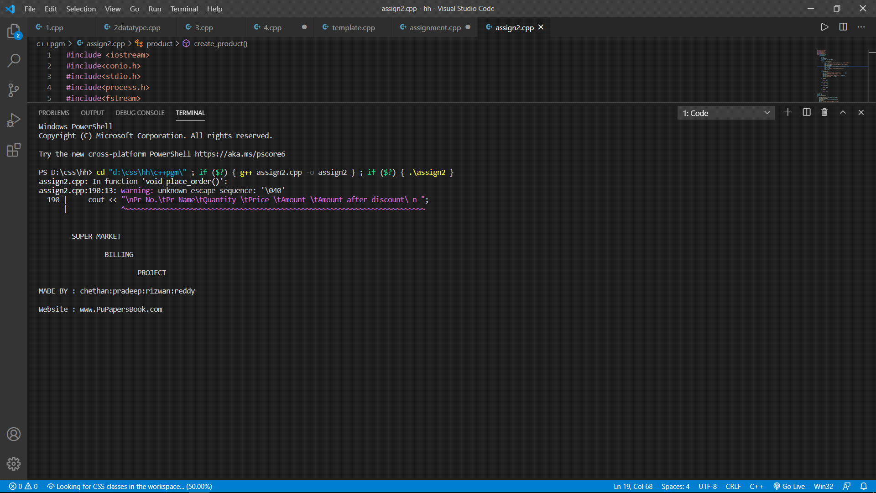****add product:*

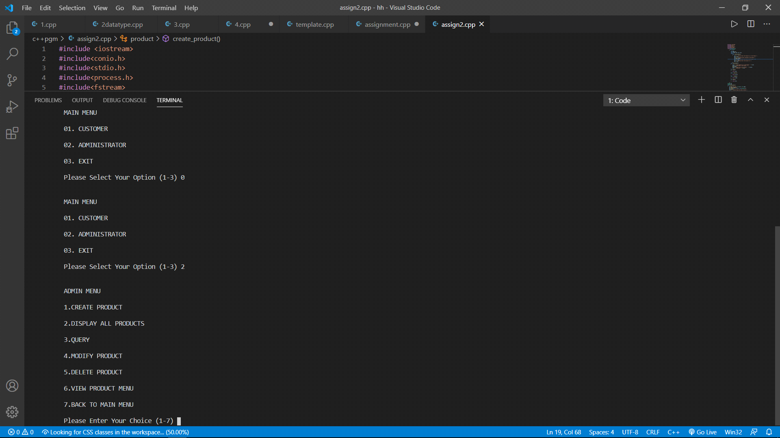add product

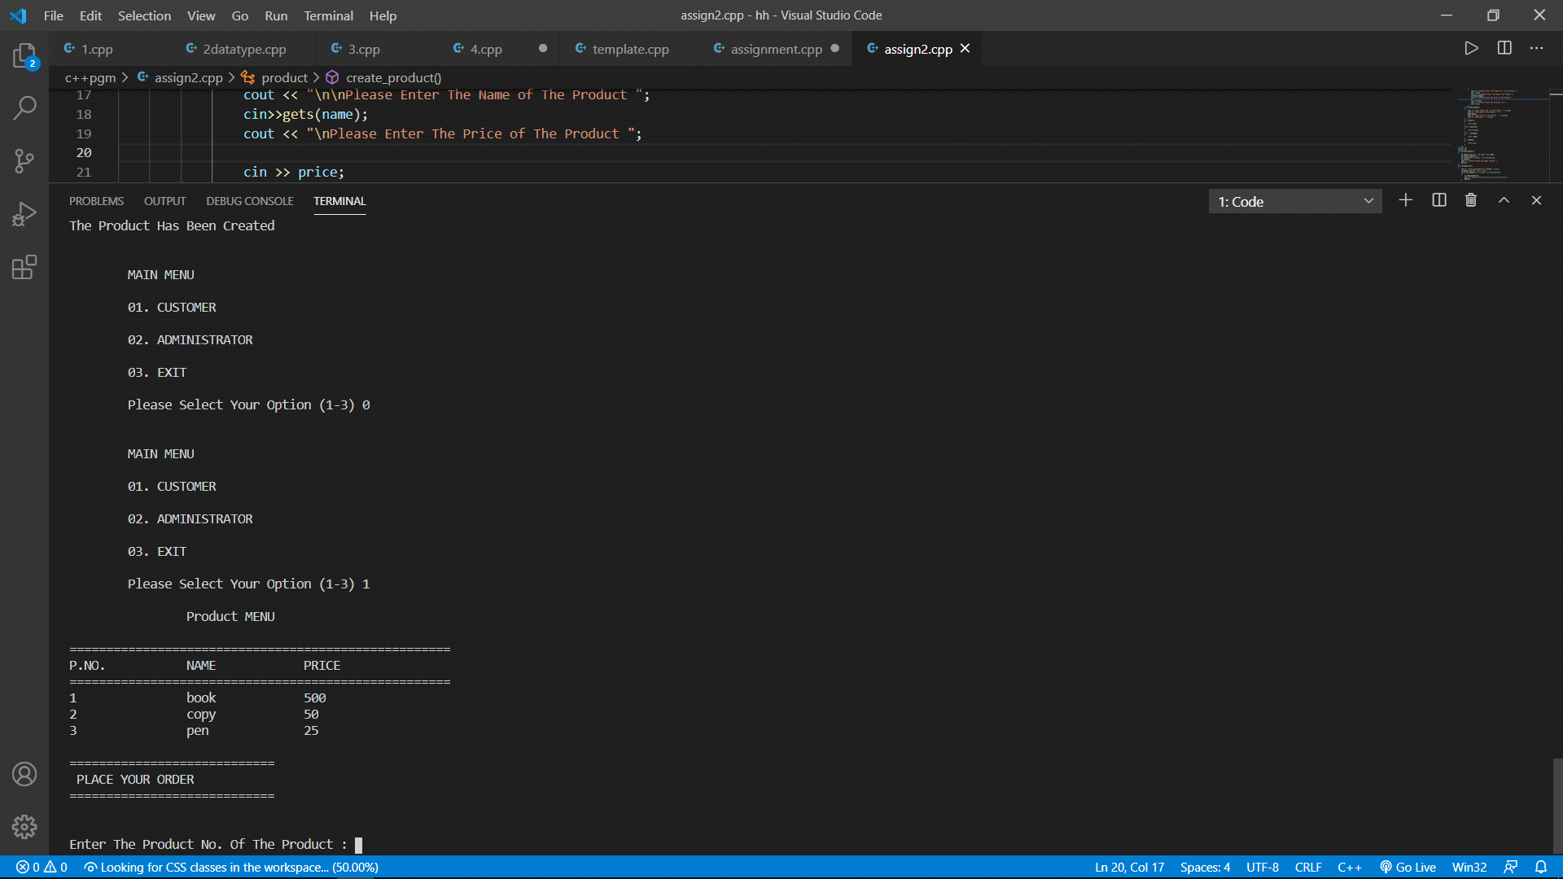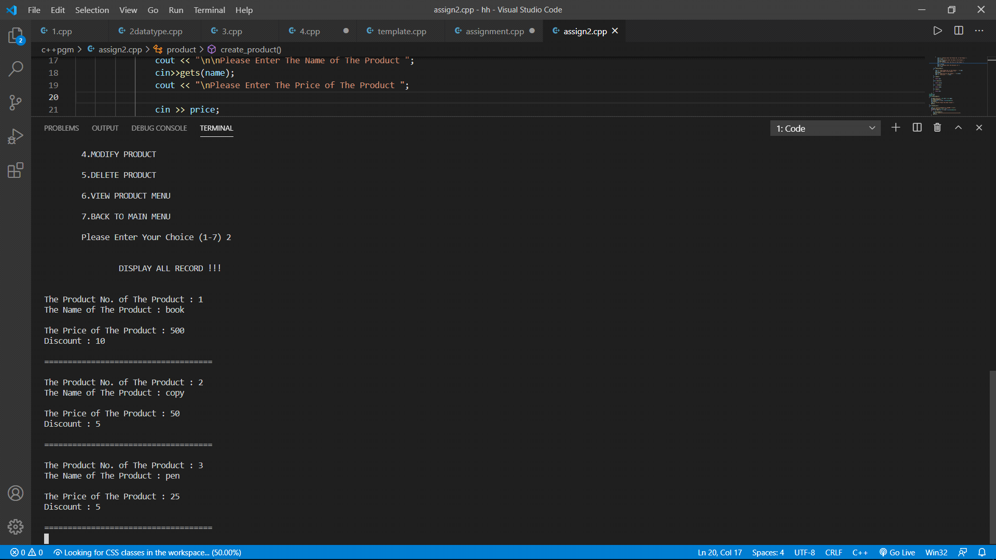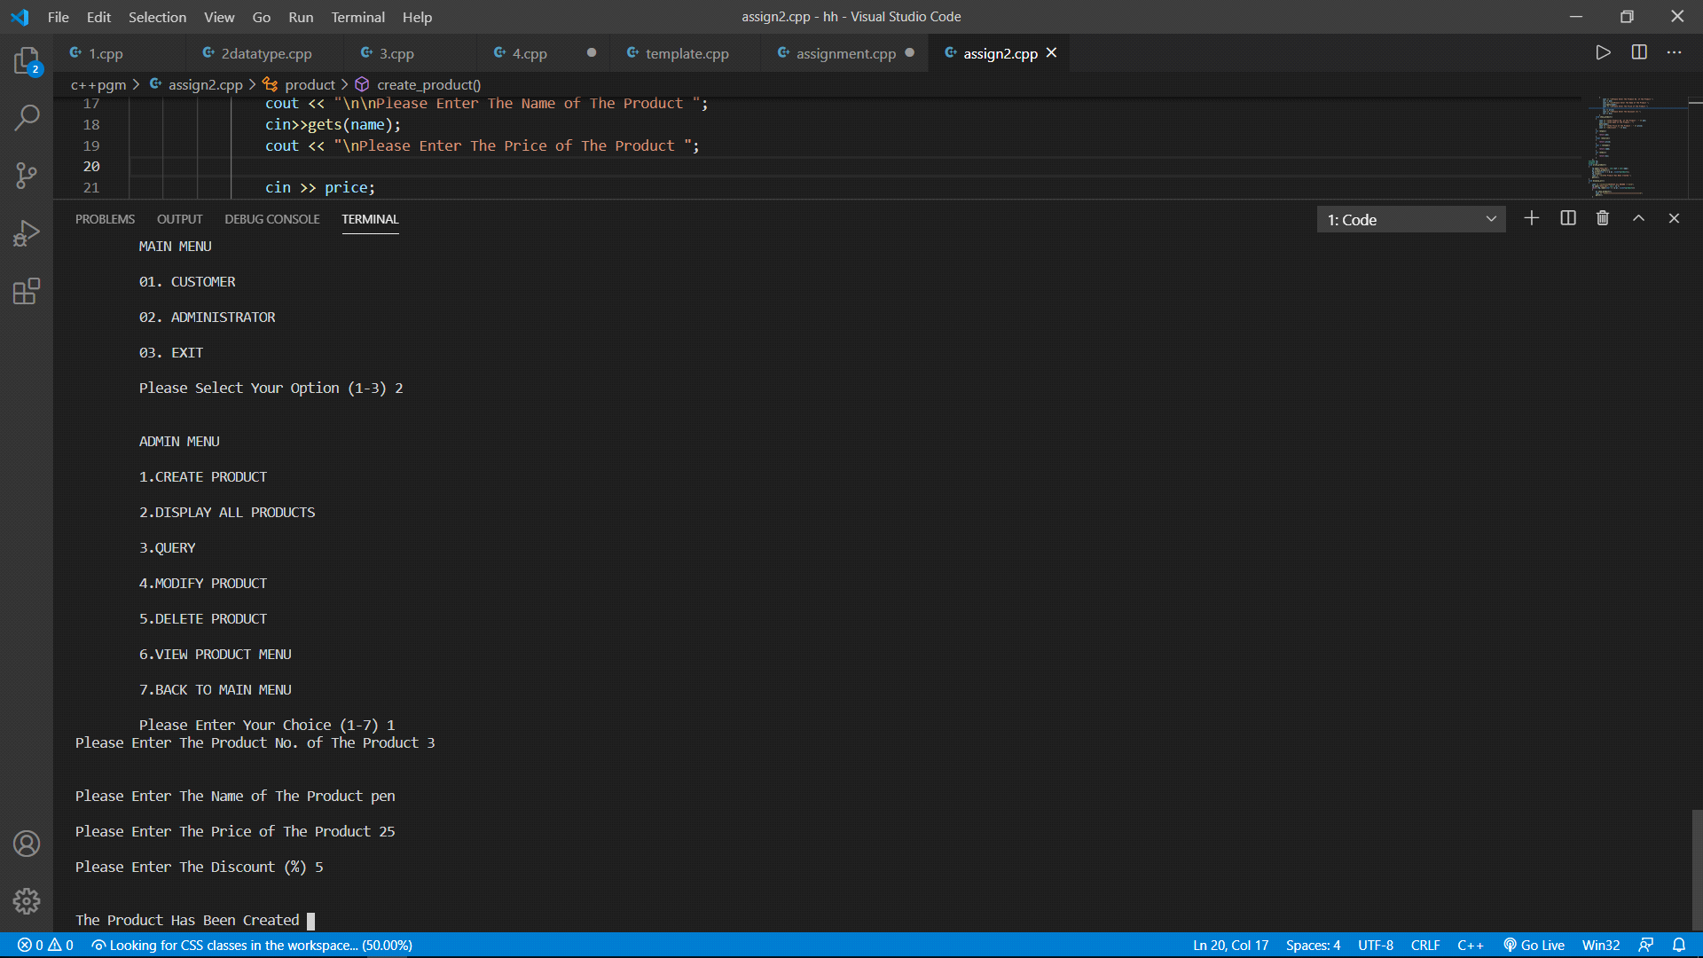

***Bill or Receipt***

